**MAVEN 3.8.4:-**

Download the maven bin file from official site or RMG Google drive

<https://drive.google.com/drive/folders/1cxQXtR70rJHLmG1eneIwyuHNFikcOcuV>

extract the file using 7-Zip or any extracting application

open the extracted folder and copy the file and paste it inside program files folder in C:\\ Drive.

Navigate **C:\Program Files\apache-maven-3.8.4\bin** and copy the path

Right click on **This PC** and click on **properties**

Click on **Advanced system settings**

Click on **Environment variables**

In the **Uservariable 🡪** click on new 🡪 enter **MAVEN_HOME** variable_name🡪 enter **C:\Program Files\apache-maven-3.8.4** variable_value

In the **Systemvariable 🡪** search **path** variable 🡪click on edit 🡪 click on new🡪 enter **C:\Program Files\apache-maven-3.8.4\bin**

Click on **ok , ok, ok**

**Make sure wheather maven installed or not:-**

Open fresh instance of command prompt 🡪 type **mvn -version**

**How to Install Maven on Windows**

Follow the steps outlined below to install Apache Maven on Windows.

**Step 1: Download Maven Zip File and Extract**

1. Visit the [Maven download page](https://maven.apache.org/download.cgi) and download the version of Maven you want to install. The *Files* section contains the archives of the latest version. Access earlier versions using the archives link in the *Previous Releases* section.

2. Click on the appropriate link to download the binary zip archive of the latest version of Maven. As of the time of writing this tutorial, that is version 3.8.4.

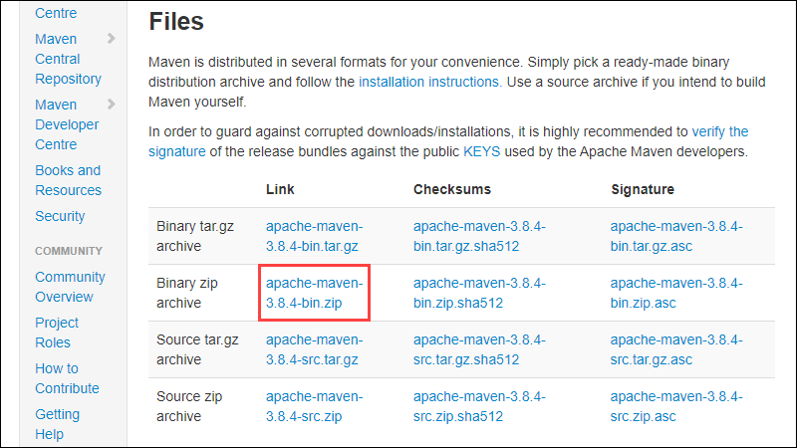

3. Since there is no installation process, extract the Maven archive to a directory of your choice once the download is complete. For this tutorial, we are using *C:\Program Files\Maven\apache-maven-3.8.4*.

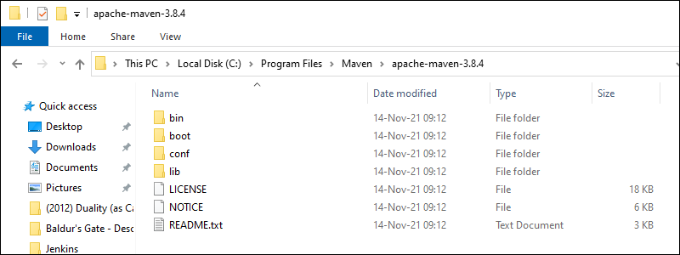

**Step 2: Add MAVEN_HOME System Variable**

1. Open the Start menu and search for [environment variables](https://phoenixnap.com/kb/windows-set-environment-variable).

2. Click the **Edit the system environment variables** result.

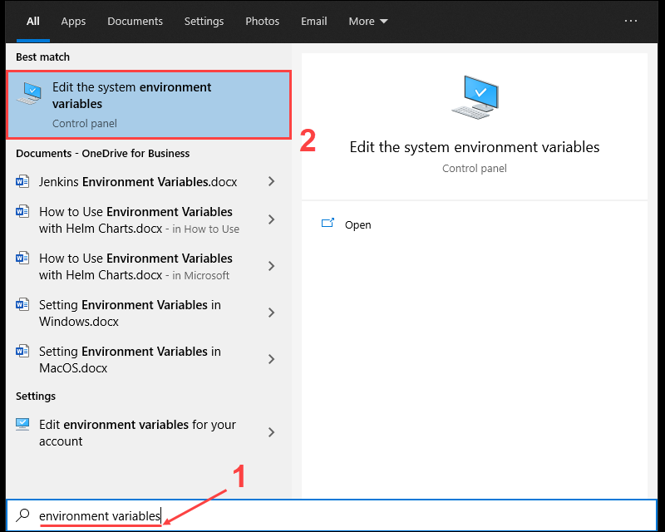

3. Under the *Advanced tab* in the *System Properties* window, click **Environment Variables**.

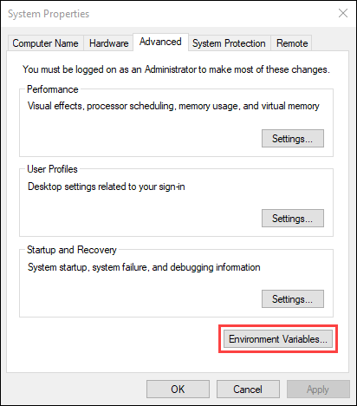

4. Click the **New** button under the *user variables* section to add a new system environment variable.

5. Enter **MAVEN_HOME** as the variable name and the path to the Maven directory as the variable value. Click **OK** to save the new system variable.

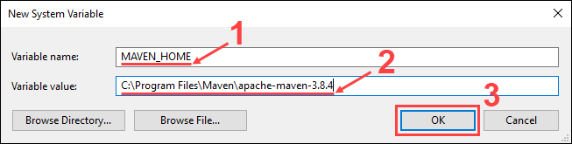

**Step 3: Add MAVEN_HOME Directory in PATH Variable**

1. Select the **Path** variable under the *System variables* section in the *Environment Variables* window. Click the **Edit** button to edit the variable.

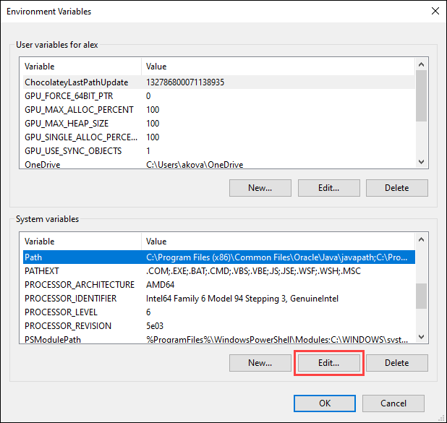

2. Click the **New** button in the *Edit environment variable* window.

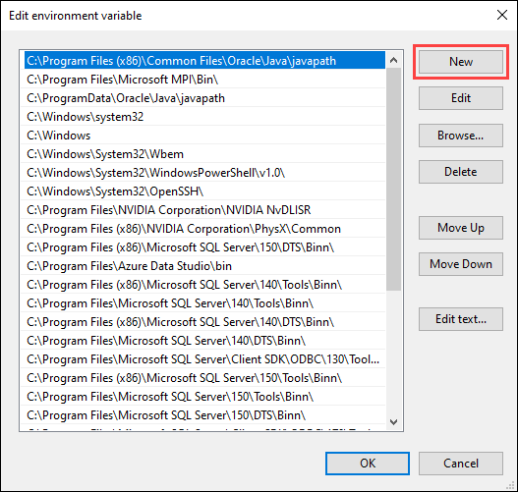

3. Enter **%MAVEN_HOME%\bin** in the new field. Click **OK** to save changes to the **Path** variable.

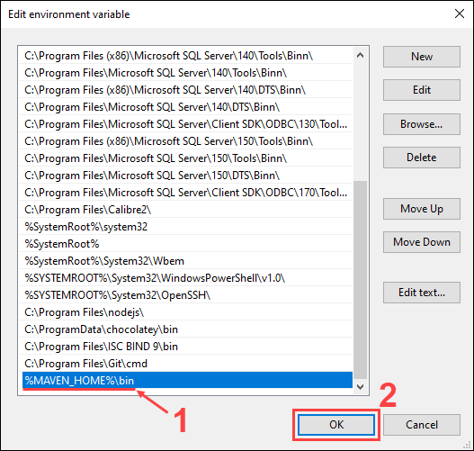

**Note:** Not adding the path to the Maven home directory to the **Path** variable causes the **'mvn' is not recognized as an internal or external command, operable program or batch file** error when using the **mvn** command.

4. Click **OK** in the *Environment Variables* window to save the changes to the system variables.

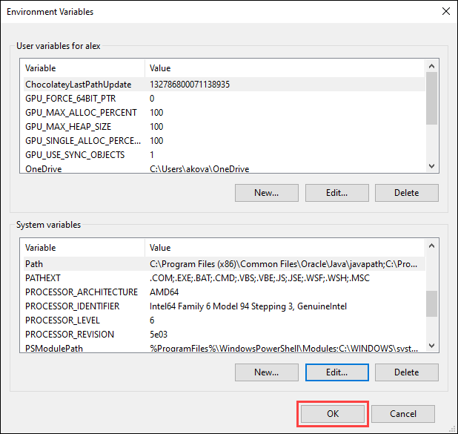

**Step 4: Verify Maven Installation**

In the command prompt, use the following command to verify the installation by checking the current version of Maven:

mvn -version

